Recent destructive earthquakes and international collaboration for seismic hazard assessment
ª Ken XS Hao and ª Hiroyuki Fujiwara
ª National Research Institute for Earth Science and Disaster Prevention, Japan, hao@bosai.go.jp

Recent destructive earthquakes in east Asia, such as 1976 Tangshan, 1995 Kobei, 1999 Jiji, 2008 Wenchuan, 2010 Yushu, 2011 Tohoku earthquakes, claimed a half million of people’s lives. People learned from lessons but forgotten after generations even one sculpted on stones. Probabilistic Seismic Hazard Assessment (SHA) in long-term is considered as a scientific way to define earthquake zones and to guide urban plan and construction.
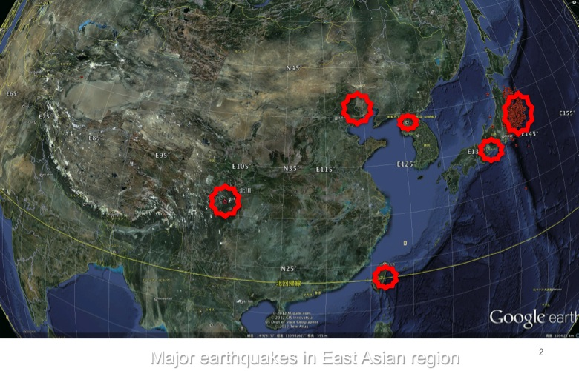
Fig. 1. Major earthquakes in East Asian region (by Hao et al 2012).
NIED promoted SHA national mission in Japan over 10 years and extended to neighbor countries since the 2008 Wenchuan earthquake.
We initiated China-Japan-Korea SHA strategic cooperative program for the next generation map supported by MOST-JST-NRF in 2010. We also initiated cooperative program with TEM (Taiwan Earthquake Model committee) from 2012, as well many other parties in the world. Consequently NIED proudly joined GEM (Global Earthquake Model Foundation) since its SHA’s methodologies and technologies were highly valuated. Our international promotion activities in East Asian could be automatically becomes one of the GEM Regional Programs. We have setup a platform of http://www.j-shis.bosai.go.jp/en to exchange the SHA information and share our experiences, lessons and knowledge internationally. Some probabilistic SHA concepts, seismic risk mitigation issues are constantly needed to promote international through outreach and media.

References
Hao K. and H. Fujiwara (2012), Should worst-case scenario of Mega-earthquake be considered in East Asian region, the lessons learnt from recently destructive earthquakes, http://www.j-shis.bosai.go.jp/intl/cjk/2nd_annual_meeting.html

